Abstract
Pennsylvania is one of a number of U.S. states which provide incentives for the generation of electricity by solar energy through Solar Renewal Energy Credits (SRECs). This paper develops a return on investment model for solar energy generation in the PJM (mid-Atlantic) region of the U.S. Model results indicate that previous capital investments in solar generation have been stranded due to steep declines in the value of SRECs. A simple conceptual supply and demand model is developed to explain the sharp decline in market prices for SRECs and a possible policy remedy that would provide more graduate price signals to the market is discussed.
Keywords: US, Solar Renewable Energy Credit, Residential solar PV
Introduction
Increasing of greenhouse gases’ emissions has caused so much concern and has made governments to react. Carbon dioxide emissions have increased 0.4% per year from 1990 to 2009 (Cleantechnica). For its energy purposes, the United States depends strongly on fossil fuels; about 67% of its electricity needs are produced from fossil fuels, including coal (40%), oil (1%), and natural gas (26%) (US Energy Information Administrationª). Electricity generation accounts for 40% of the US greenhouse gas emissions (US Energy Information Administration^{b}). So, finding renewable low-carbon ways of generating electricity is important.
Over the last decade, interest in generating green electricity has increased, however, renewable energy sources have high up front cost. To incentivize renewable electricity generation, a number of US states have developed renewable portfolio standards (RPS). Renewable Portfolio Standards require electricity companies to generate a growing quantity of their energy from renewables. Each state has developed renewable energy targets. The target objectives are tracked by renewable energy credits (REC), which are tradable commodities, allowing electricity utilities to meet their RPS requirements by purchasing power from generators using renewable sources.
In the United States, RPS policies have remarkably expanded the application of wind energy (Menz and Vachon 2006). The reason for the slower growth in solar electricity is the high initial investment required for PV systems. To alleviate the high capital cost of PV systems and make them competent with other renewable technologies, most states with RPS laws have initiated set-asides. A solar set-aside obligates that a certain amount of electricity consumed in a state must be generated by PV facilities. If a utility provider fails to meet set-aside obligations, then it must pay a penalty called the solar alternative compliance payment (SACP). These penalties are aggregated by the government and invested on research to expand renewable energy usage (Holt and Wiser 2007).
RECs specified for solar energy are called solar renewable energy credits or certificates (SRECs). To trade SREC some states have set up viable markets, which are at their initial stages in the United States and few studies are done on them (Burns and Kang 2012). Pennsylvania SREC market has not been studied in depth; in its initial years it reached considerable growth, however, its early success was not stable and was followed by a dramatic collapse in SREC prices and its solar industry (THE SOLAR FOUNDATION). Exploring Pennsylvania’s market in depth can provide insights into solar markets’ structure and help establish more functional markets. Thus, the objective of this paper is to explore the Pennsylvania SREC market and effective returns on investment in the solar electricity generation given historical market fluctuations in SREC value. Also, the implications of proposed plans to strengthen the Pennsylvania market will be discussed.
Our preceding introduction comprises Section 1 of this paper. Five sections follow: Section 2 is a succinct background and Section 3 provides a history of the Pennsylvania SREC market, its current status and the challenges it faces. Section 4 presents the cost estimation and economic returns of a typical PV system. Section 5 offers the results of the analysis and strategies to improve the stability of the market. Section 6 is the conclusion.
Background
Support mechanisms for renewable resources were first introduced in Europe through feed-in-tariff programs in 1980s. FIT is energy specific mechanism and incentivizes various energy production technologies with accordance to its cost. Furthermore the government insures purchase of all produced green energy by signing long-term contracts with producers. As a result solar electricity production, which is relatively expensive, is well stimulated in Europe (Lipp 2007, Dusonchet and Telaretti 2010). In the USA, however, green energy production is supported through RPS, which is implemented at state level. It requires that a growing percentage of consumed electricity be produced from renewable resources. As of 2016, 29 states, the District of Columbia, and Puerto Rico have instituted a renewable portfolio standard (RPS). States are free to structure their RPS program according to their specific goals and associated characteristics. For instance, while New Jersey does not have any constraints on the capacity of the PV systems, Pennsylvania requires that PV systems be smaller than 50 kW to be eligible to register and trade their generated electricity in the market.
Several researchers have discussed advantages and disadvantages of RPS programs and examined its potentials to advance renewable energies’ usage (Agnolucci, 2007; Bergek and Jacobsson, 2010; Buckman, 2011; Butler and Neuhoff, 2008; Cory and Swezey, 2007; Finon and Perez, 2007; Kildegaard, 2008; Lauber, 2004; Lipp, 2007; Michaels, 2008; Midttun and Gautesen, 2007; Mitchell et al., 2006; Pourhashem et al., 2013; Toke, 2005; Wiser et al., 2005a; Wiser et al., 2005b). Lauber (2004) compared RPS policies and feed-in-tariff models, He concluded that while RPS is beneficial, it does not contribute to the technological assortment and as indicated by Buckman (2011) it lacks “dynamic efficiency”. Similarly, Meyer and Koefoed (2003) found that most RPS policies do not differentiate between renewable resources, therefore, they do not provide much support for high cost energy sources. However, Langniss and Wiser (2003) reviewed RPS application in Texas and concluded that if an RPS is carefully designed and implemented, it can proliferate solar electricity generation at a low cost. Still, the success of RPS in Texas is primarily due to wind power, and solar electricity has a very small role in the success of Texas RPS policies.
To promote more expensive technologies such as PV and make them competent with other renewable technologies, RPS allows for implication of support mechanisms: credit multipliers and solar carve out (or set aside) are two common programs adopted by 16 states, as well as the District of Columbia. A solar set-aside obligates that a certain amount of electricity consumed in a state must be generated by PV facilities. However, credit multipliers encourage PV installation by devoting a higher credit to RECs generated by PV facilities in comparison with other renewable resources. As mentioned earlier, RECs specified for solar energy are called solar renewable energy credits or certificates (SRECs). An SREC is equal to one-megawatt hour of green electricity generated by utility companies, homeowners, or by any private entity, and it can be traded in a solar market. Unlike tax credit or cash rebates that compensate individual investment near the time of the PV installation SRECs shift the return on solar investment to the future. One major concern about SRECs is that they do not have a fixed value. Thus, changing prices makes financing projects supported by SRECs risky.
To date 8 states (Delaware, Massachusetts, Maryland, North Carolina, New Hampshire, New Jersey, Ohio and Pennsylvania) and District of Columbia have set up markets and associated tracking facilities to trade SRECs. In these markets, commercial solar energy generators, as well as individual PV installer can sell their SRECs to utility providers. To be permitted to participate in such markets, generators are required to get a participation number and then register in an eligible market. Furthermore, they are required to install certain device to allow counting of their generated SRECs. One drawback of such markets is that residential PV installers usually do not possess the knowledge to perform successfully in these markets. However, there are SREC brokers that can act as intermediaries. States with solar carve-outs but no SREC market (New York, Illinois, Indiana, Kentucky, Michigan, Tennessee, Virginia, Wisconsin and West Virginia) can sell their SRECs in out-of-state eligible markets. For instance, solar investors in West Virginia are allowed to participate in Pennsylvania market.
In addition to SREC, there are other support mechanisms for PV installations. For example, the federal investment tax credit (ITC) is a non-refundable personal tax credit that only residential PV owners can apply for. Since January 1, 2006 the federal government gives residential PV installers a credit equal to 30% of their PV systems’ expenditures up to $500 per 0.5 kW of power (DSIREª). The ITC will expire at the end of this year (Dec 2016). Furthermore, some states like Massachusetts and North Carolina offer PV installers tax credits. Besides, cash rebates, which are a dollar amount paid per watt-capacity of the PV system, are available in many states. However, cash rebates usually suffer from lack of funding. They are offered based on first-come, first-served, and they are not guaranteed.
SREC markets are at their initial stages in the United States and few studies are done on them. Burns and Kang (2012) presented a short history of SREC markets and current regulations in eight US states. They performed a financial analysis for a residential case study to compare the returns on investment in existing SREC markets. However, they left Pennsylvania and North Carolina out of their economic analysis due to the high uncertainty of SREC markets there. Gual and Carely (2012) investigated the effectiveness of solar set-asides in North Carolina. They concluded that obscurity in the SREC market and uncertainty associated with current and future SREC prices hinder the advancement of solar PV systems in North Carolina.
At the initial years of its SREC market, Pennsylvania had a secure solar market and achieved notable growth in its local solar industries. However, its early success was not stable and was followed by a dramatic collapse in SREC prices and its solar industry (THE SOLAR FOUNDATION). Therefore, exploring Pennsylvania’s market in depth can provide insights into solar markets’ structure and help establish more functional markets. Furthermore, the Pennsylvania market has not been considered by either Gual and Carely or Burns and Kang. Thus, the objective of this paper is to explore the Pennsylvania SREC market and effective returns on investment in the solar electricity generation given historical market fluctuations in SREC value. Also, the implications of proposed plans to strengthen the Pennsylvania market will be discussed.

The Pennsylvania SREC market
The Pennsylvania RPS program is entitled Alternative Energy Portfolio Standard (AEPS) and was created by Senate Bill 1030 on November 30, 2004 and the solar set-aside program took effect in 2007 as a result of Bill 1203. Pennsylvania aims for 18% green electricity by 2021, and its solar set-aside is 0.5%. Pennsylvania established its solar market in 2009, and it called an SREC a solar alternative energy credit (SAEC). The Public Utility Commission and the Pennsylvania Department of Environmental Protection are responsible to implement the AEPS act (DSIREª). SRECs generated in Pennsylvania are valid in the year generated and the next two years.
There are several regional transmission organizations in USA and Pennsylvania is part of the PJM (Mid-Atlantic) region. In addition to Pennsylvania, PJM Interconnection is responsible to provide electricity in Delaware, Illinois, Indiana, Kentucky, Maryland, Michigan, New Jersey, North Carolina, Ohio, Tennessee, Virginia, West Virginia, and the District of Columbia. Pennsylvania’s SREC market is an open market and any facility smaller than 50 kW that is located in the PJM region can register to trade its SRECs in Pennsylvania’s market. However, Pennsylvania’s solar electricity can sell theirs SRECs merely in Pennsylvania and Ohio. In the PJM region, New Jersey was the first state to initiate an SREC market (in 2005) and has the highest solar target (>4 GW by 2025). Although Pennsylvania almost has the highest electricity consumption (24%) in the PJM region, it has the smallest target for solar electricity (0.5% by 2021; see Figure 1) and its SREC’s requirement is of the smallest in the region.
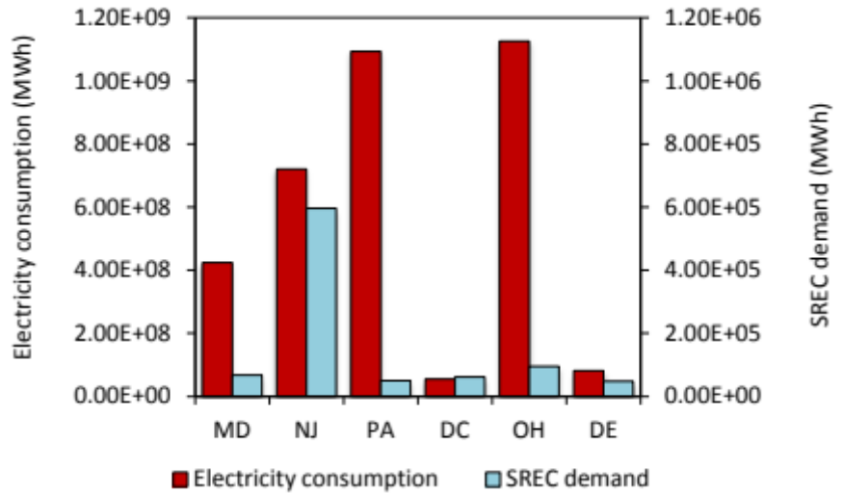
Figure 1. Electricity consumptions and SREC demands in PJM region (Trabish, 2012). Pennsylvania has approximately the highest electricity consumption in the Mid-Atlantic region but it has a very small solar market and it aims for 0.5% solar electricity by 2021. To find electricity consumption for each state, electricity consumption per capita (U.S. Energy information administration^{c}) is multiplied by its population (State population). Note that scales of the two axes are not similar.

As noted earlier, SACP is a support mechanism to stabilize SREC prices. SACP can act as a price ceiling, and if it is high enough, it could increase the SREC demand and stimulate PV installment. To benefit from SACP supportive potentials, many states have defined long-term schedule for SACP values. However, Pennsylvania does not have a pre-fixed value for the SACP. It is calculated at the end of the compliance year (June 1-May 31) and it is approximately 200% times the average SAEC (SREC) price traded during that year. Therefore, it is very difficult to predict SREC prices in Pennsylvania.
SREC price trends for markets in the PJM region are shown in Figure 2. In 2011, SREC values in the Pennsylvania market began to decrease and dropped from an average of $290 to $10. The Pennsylvania House of Representatives reacted and Rep. Chris Ross introduced House Bill 15180 on October 3rd, 2011 to strengthen the Pennsylvania SREC market. The amendment would have modified the eligibility criteria and not allow out-of-state SRECs to be traded in Pennsylvania. Furthermore, the bill required an increase in the state’s solar carve-out for the period from 2012 to 2015 in order to stabilize the SREC market and resolve the oversupply issue (SRECTradeª). The bill’s implementation would have increased electricity prices and would have imposed approximately $120 million in costs distributed amongst all residential and commercial power users in Pennsylvania. However, this increase would not have exceeded fourteen cents per Pennsylvanian homeowner over five years (Gaul, 2012). Still, utility providers did not support the bill and it failed. Consequently, Pennsylvania’s SREC prices continued to decrease and reached $15 by the end of 2012. For energy year 2013 (June 2012 to May 2013). SRECs generally fluctuated between $10 and $20. There was a rally in early 2014 with prices in the $50-$60 range in the first half of the year but falling into the $30-$40 range in the later part of the year and into early 2015. Prices eroded over the course of 2015 and were at or near $10 for the first half of 2016 (Flettexchange, SRECTrade^{b}).
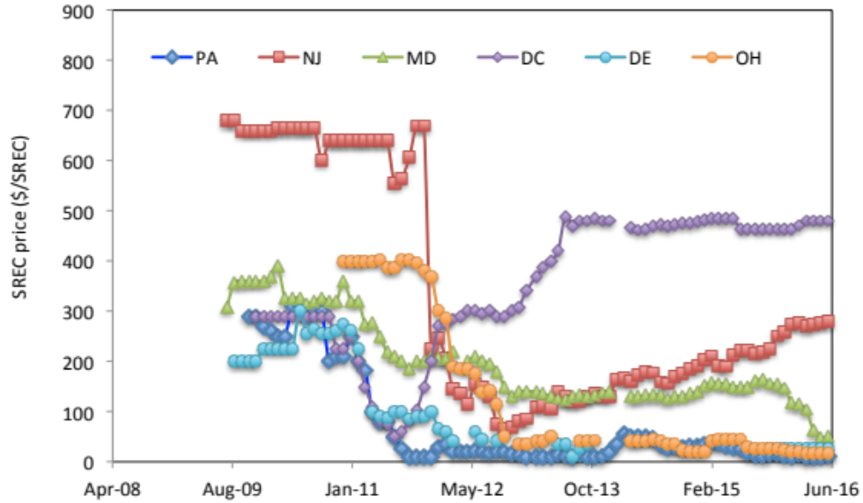
Figure 2. SREC price trends in PJM region.
One of the reasons for the Pennsylvania market oversupply is the coincident emergence of different incentive programs. In 2009, when the Pennsylvania SREC market was instituted, there were two other major support programs incentivizing PV installations: the federal investment tax credit (ITC) and the Pennsylvania sunshine program. The ITC returns PV installers 30% of their initial investment in the form of the tax credit. The Pennsylvania sunshine program was initiated in 2009, and it returns 35% of the PV system installation cost in the form of rebate (DSIRE^{b}). The overlapping of these bountiful incentive programs as well as high SREC prices jump-started the PV installation and as a result too many SRECs were generated that interfered with the market balance.
Furthermore, Pennsylvania’s RPS requirement for PV installation is very small, and as is shown in Figure 3, the current capacity of PV systems installed is almost twice the RPS mandated capacity for 2015.
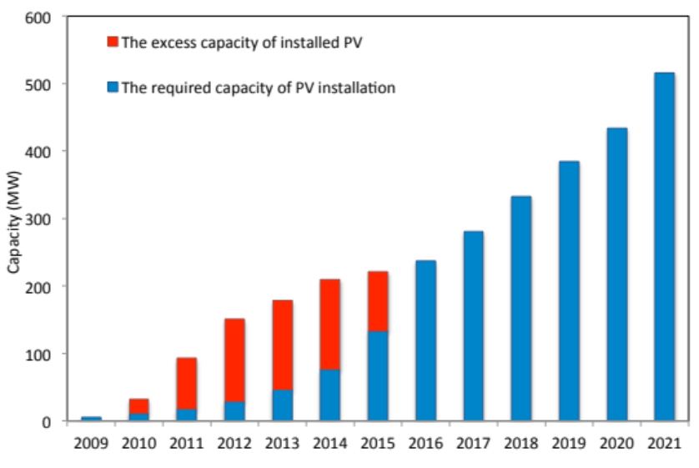
Figure 3. Pennsylvania solar RPS requirement (SRECTrade^{c}) and current installation capacity (SRECTrade^{d,e,f,g,h}). The overlapping of generous incentive programs (the federal tax credit and Solar Sunshine rebate program) and high SREC prices caused a short-term boom in PV system installation.
When the generation capacity for SREC exceeded what the RPS law required utility companies to buy, there was a dramatic drop in SREC prices. This may be understood by considering the shape of the supply and demand curves for SRECs. As shown in Figure 4, utilities will pay p* (where p* is the legislated penalty for failing to obtain sufficient SRECs) for quantities up to Q* (where Q* is the legislated mandatory quantity of SRECs to purchase). Given that the marginal costs of generation electricity from PV panels is essentially zero (once the panels have been installed), the generators are essentially price-takers and generate their maximum capacity, regardless of price. This leads to a stable price p* until capacity exceeds Q*, at which point the price collapses to zero. A legislative mandate increasing Q* can restore price stability (at the expense of higher electricity costs) at least until installed capacity grows further.
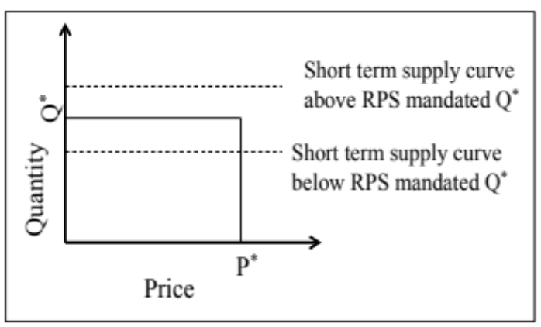
Figure 4. SREC demand curve. The solid line indicates the SREC demand curve. Utilities are willing to pay the SACP, P*, up to the mandated minimum quantity Q*. Above Q* willingness to pay declines to zero. When the short-term supply curve (shown by the dashed line) for SRECs is below Q*, the equilibrium price is P*. When the short-term supply curve exceeds Q*, the price collapses to zero.

According to Figure 3, based on present installed PV capacity, Pennsylvania’s market will be oversupplied until 2015. It can be inferred that in order to stabilize the SREC market, PV installation must be controlled. Since, Pennsylvania has the smallest SREC requirement in the PJM region, and it allows out-of-state SRECs to be used to meet PA SREC requirements, its market is very sensitive to oversupply.
As can be seen, there is a great deal of volatility and political risk associated with the SREC market. Such volatility creates a risk of stranded capital where an investment is made under conditions conducive to a positive return but subsequent market changes erode the return on investment. This paper conducts an economic analysis to determine if SREC prices have created a problem of stranded capital for investors.
Methods
This section first describes briefly the assumptions we made to estimate the capital cost for a PV system. Then, it offers a cost-benefit analysis for the system. Also, breakeven point analysis is done to determine the SREC floor price. The PV system design and the cost estimation model are described fully in the supplement.

Cost estimation model
Residential PV systems usually have power between 2-10 kW_{p} (Burns and Kang, 2012). We have assumed the mean value of 6 kW_{p} for the PV array size to do our cost-benefit analysis. Furthermore, it is assumed that the PV system is connected to the electric grid. Therefore, there is no need for storage batteries and the system can benefit from the net metering. In sunny days that generated electricity is more than the building’s demand, surplus energy can be fed to the grid and on cloudy days that the amount of energy produced is not enough to meet the building’s electricity requirement, grid electricity will be used.

Economic Analysis
The objectives of the economic analysis are 1) to find out if the asset’s benefits would outweigh the costs during the lifetime of the PV system and 2) to determine the required SREC value to allow investors to recoup their costs. Financial criteria used in this study are net present value (NPV) and time to achieve zero project balance. The NPV takes into account inflation and returns and it is a comparison between the current and the future values of money. A positive NPV indicates that a PV system project benefits from positive cash inflows during the PV system’s lifetime. Time to achieve zero project balance is the duration needed for an investor to gain back their initial investment. The shorter this time is, the more profitable the project is.
In order to find NPV, the annual cash flow of the system must be calculated. The annual cash flow is the difference between the cash inflows and outflows during any year. The SREC revenue, electricity savings, and incentives are the inflows to the system. Depending on the location, different incentives are available. In this study we consider the federal investment tax credit. However, we ignore state-level programs such as rebates, grants, and loans because they are not always available. During the lifetime of a PV system, it requires maintenance and insurance, which are outflows and are negative. The PV system annual cash flows can be estimated as follow:
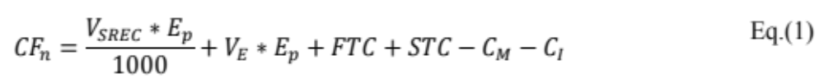
Where CF_{n} is the cash flows in year n, V_{SREC} is the annual average price of SREC in $/Mwh in year n, E_{P} is the amount of produced electricity in kWh in year n and V_{E} is the electricity price per kWh in year n. FTC is the federal tax credit in dollars (as a percentage of the initial cost) assumed to be paid at the end of the first year. STC is the state tax credit if it is available. Only Maryland has a tax credit for PV installers. It gives $0.0085/kWh for the produced electricity for the first 5 years of PV system (DSIRE^{c}). C_{M} and C_{I} are the annual maintenance and insurance fees, and they are 0.5% of the PV system capital cost (Burns and Kang, 2012). Electricity price is not constant and is based on a 20-year average escalation rate reported by Burns and Kang (2012). SREC, electricity prices, and the electricity escalation rates are shown in Table 1.
To calculate the net present value of the PV system, annual cash flows during the lifetime of the PV system are first discounted, then they are summed, and finally the initial investment, C₀, is subtracted as illustrated in Eq.(2).
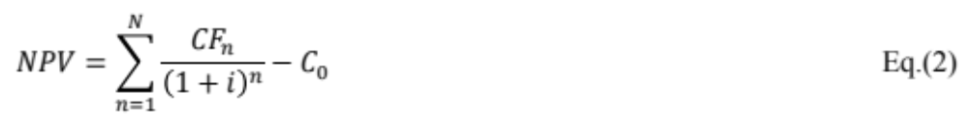
The discount rate is i and N is the project lifespan, which is 25 years. The discount rate used in this study is 3% (Burns and Kang, 2012). Project balance at early years of the PV system is negative due to the substantial initial investment. It gradually increases because of savings of electricity production and SREC generation. Time to zero project balance, pb, is the first time when the project balance becomes equal or bigger than zero: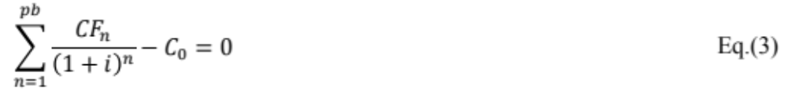
Also, in order to find the required SREC value to allow investors to recoup their costs in different states, a breakeven point analysis is done. This threshold is the minimum SREC price required to make the net present value greater than zero at the end of the PV system’s lifetime, 25 years. Any factor in Eq.(1) that affects the NPV can affect the break-even point value: the capital cost, electricity price, the amount of produced electricity, maintenance and insurance fees, federal and state tax credits. One factor that affects the SREC breakeven point and is not apparent in Eq.(1) is the PV system size: the smaller a PV system is, the higher initial investment per watt ($/watt) it requires. To find SREC floors, we first estimate the capital cost of PV systems with capacities between 2-10 kW_{p} using the model developed in this paper. We then calculate the NPV with ascending values of SREC, and recorded the value where NPV became positive.

Results and discussion
Table 1 outlines the capital cost of the system, NPV and time to achieve zero project balance (discounted payback time) for each of the states. Also, electricity price, electricity escalation rates and SREC prices used in economic analysis are illustrated in Table 1. The project balance of the system over time for each state is shown in Figure 5. Unlike the analysis of Burn and Kang (2011), which found that the initial investment would be recovered in all states approximately within 15 years, our study shows that in four states current market prices do not allow for positive return on investment. Only in the District of Columbia and New Jersey the returns on investment happen within 7 and 10 years respectively. Consequently, there is a concern that past PV investments have become stranded capital in other four states.
Table 1. Electricity prices, escalation rates and SREC prices used in this study, PV capital costs, NPVs and payback times for a PV system with a capacity of 6 kW located in different states.
State | Electricity priceª ($/kWh) | Electricity escalation rateª | SREC price^{b}  ($/MWh) | PV Capital cost ($/watt) | NPV ($) | Time to zero project balance (year)
DC | 0.1401 | 0.002807 | 480 | 5.88 | 60920 | 7
DE | 0.1380 | 0.002199 | 25 | 5.62 | -5102 | Not within project lifetime
MD | 0.1432 | 0.002329 | 140 | 5.9 | -4517 | Not within project lifetime
NJ | 0.1657 | 0.001778 | 131 | 5.94 | 32031 | 10
OH | 0.1132 | 0.000178 | 16 | 5.87 | -18282 | Not within project lifetime
PA | 0.1270 | 0.000735 | 10.75 | 5.99 | -11596 | Not within project lifetime
- Burns and Kang (2011)
- SRECTrade^{b}.
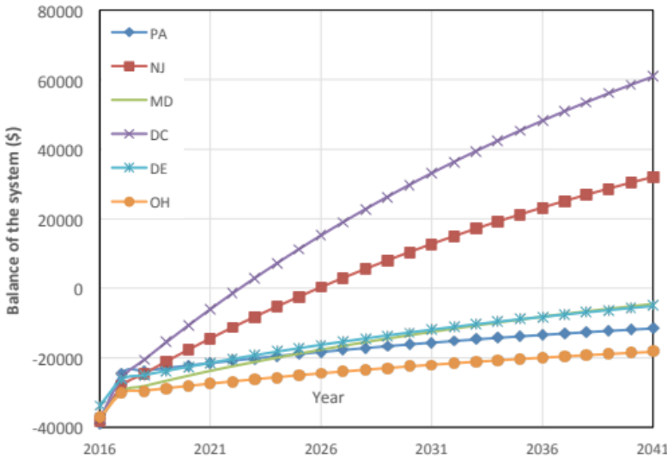
Figure 5. Project balance of PV system investments by jurisdiction.

NPV calculations are done based on the current SREC prices (Jun 2016) and it is assumed that they will be constant and equal to the values reported in Table 1 during the lifetime of the PV system. PV installation is economically beneficial only in the District of Columbia, and New Jersey. The reason for the success of the District of Columbia, and New Jersey is the higher value of SREC ($480and $279.50 respectively) in these markets in comparison with other states. This is an indication of the important role of SREC in PV system cost recovery. As can be seen in Figure 5, Pennsylvania and Ohio are the worst states for PV installation. They are both severely oversupplied, and there is a high risk of stranded capital.
Pennsylvania and Ohio both cannot recover their initial investments due to the oversupplied market and low SREC prices. One reason for the severe oversupply in these states is that their SREC markets are both open and accept SRECs from out-of-state facilities. However, Ohio accepts out-of-state SRECs at a lower price than in-state SRECs, which can be a reason for the slightly higher NPV of Ohio. Until November 2015, a total of 523.3 MW PV systems were certified in Pennsylvania. A considerable percentage, 58% (301.9 MW), of the total Pennsylvania certifications were from out-of-state facilities (SRECTrade^{f}). This percentage has increased from the similar period in 2014 and 2013 where 43% (160.5 MW out of a total of 370.4 MW) and 41% (126.6 out of 311.9 MW) of the certifications were for facilities outside of Pennsylvania. Apparently, Pennsylvania is attracting out-of-state PV installation rather than supporting local solar industry. Therefore, one way to support the PA oversupplied market could be to ban out-of-state SREC transactions in the PA market. However, the Senate Bill proposed to strengthen the Pennsylvania market (SB 1350) still allows out-of-state SRECs certification.
While Maryland, Ohio, and Delaware have pre-determined values for SACP, SREC markets in these states are still oversupplied. Therefore it can be concluded that the SACP mechanism is not enough to stabilize SREC markets at a reasonable price that assures investment return. According to the historical SREC prices shown in Figure 2, SREC prices have been falling continually in all of the states except the District of Columbia and New Jersey. Prices in the District of Columbia have been stable since 2013 and the reason for its high prices is that it is the only under-supplied SREC market. Its 2015 RPS requirement was approximately 66 MW of which only 37.9 MW have been fulfilled (SRECTrade^{i}). It is possible that the high SREC price in the District of Columbia would attract PV installation and in the near future, as a consequence of too many installations, the SREC market in the District of Columbia could become saturated and the SREC price could fall. New Jersey has the oldest and biggest SREC market in the PJM region and it also supports PV installation by defining a pre-fixed SACP. It can be concluded that setting aggressive solar carve-out, which assures that the market is undersupplied, along with defining high pre-fixed SACP values may guarantee promotion of PV installation.
As mentioned earlier, another means to provide price stability would be to mandate a lower limit on the SREC price. In order to find the minimum SREC value that allows investors to recoup their costs in different states, a breakeven point analysis was done and the chart of the breakeven points versus system size for different states is illustrated in Figure 6. As the PV system size decreases, the installation cost per watt ($/watt) increases and higher SREC prices are needed. The difference in SREC breakeven prices for different states is due to the different hours of sunshine in each state and also different energy prices. For a system of a certain size, the more sunshine hours a state has, the more electricity will be generated. Consequently more SRECs are generated and a lower SREC price is needed to recover the upfront costs. Also, states with higher electricity prices are better suited for PV systems, because they gain more cash inflows from selling electricity to the grid and consequently they require less incentive to recover the initial investment. As can be seen in Figure 6, in Pennsylvania, if the SREC price falls under $195/MWh, PV systems with small capacities of 2kW_{p} will not be able to recover their capital investments. This SREC price is far above the early 2016 market price of about $10/MWh
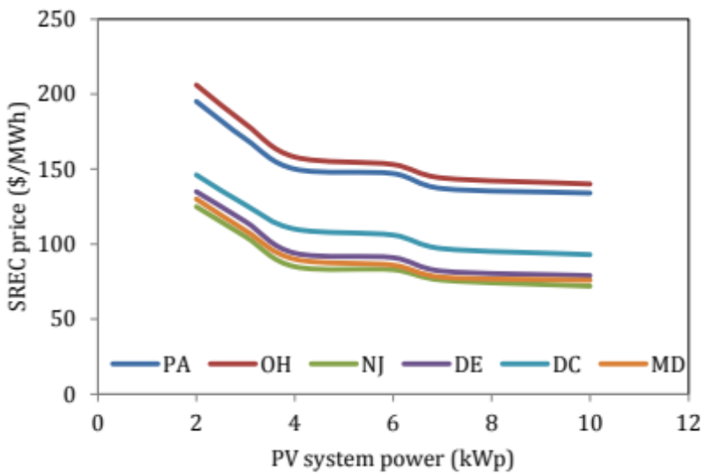
Figure 6. SREC price breakeven values as a function of the system size.
The new senate bill (SB 1350) will allow solar thermal facilities to register for SREC tracking in Pennsylvania. This merits further discussion. According to the NREL report of Nov 2010, the levelized cost of energy (LCOE) for solar thermal facilities in 2015 is predicted to be $181/MWh while LCOE for PV systems will be $270/MWh (Tidball et al., 2010). LCOE is the investment required to install a renewable energy system divided by its expected energy output during its lifetime. The initial capital cost, discounted rate and maintenance cost are included in LCOE. Since the cost of energy production for solar thermal facilities is considerably smaller than PV systems, investing in solar thermal is favored over PV modules. This may cause another boom in SRECs generation and flood the SREC market with thermally generated SRECs, while past investments in PV remain stranded. If thermal facilities are intended to participate in the SREC market, it is essential to differentiate thermally generated SRECs from PV facilities. One way could be to use credit multipliers. For instance, SRECs generated from PV facilities can be given a multiplier of one while thermally generated SRECs are given a multiplier of 0.67 (LCOE of thermal facilities, $181/ LCOE of PV systems, $270). In determining multipliers, it is important to have multipliers lower than one for non-PV systems; if we define multipliers as 1 for thermal facilities and 1.49 (1/0.67) for PV systems, then, while the number of the SRECs generated would be enough to keep the market balanced, the real capacity of the installed solar systems would be smaller than the solar carve-out and PV installation would be surpassed.
Furthermore, the bill requires an increase in the state’s solar energy carve-out for three years starting in 2013. If the solar energy quota is determined cleverly, it can help to foster the supply-demand balance. One state that has a unique way of determining its solar quota is Massachusetts. Like Pennsylvania, the Massachusetts market was oversupplied in 2012 and 2013. Therefore, it would be interesting to briefly describe its structure and the unique mechanism it has adopted to resolve the market oversupply condition.
The Massachusetts Department of Energy Resources (DOER) created the SREC market in January 2010 and only in-state solar photovoltaic installations smaller than 60 kW are eligible to register in the Massachusetts market (DSIRE^{d}). Massachusetts has a unique method to define its solar set-aside, which helps it maintain its solar market balance. At the end of the year, if there are still unsold SRECs in the market, they are deposited in the Solar Credit Clearinghouse Auction (SCCA). The SCCA encompasses of three rounds of auctions with prices fixed at $300/SREC minus a 5% administrative fee. If at the end of the third round, the auction is not cleared, then the DOER increases the solar carve-out for the coming compliance year by the amount of unsold SRECs. This is a very intelligent way of controlling the market balance: by adjusting the next coming year’s solar requirement based on the previous year market’s performance, it is guaranteed that the SREC demand in the market is high enough to maintain the prices and also stimulate new PV installations.
As noted earlier, the new Senate Bill (SB 1350) defines an SACP of $285 per SREC until 2019 and then decreases this value by 2% annually. Over 25 years (a PV system’s lifetime), the average value of SACP will be $248 per SREC and this alternative compliance value is higher than the breakeven point of $195/SREC. This suggests that the SACP is high enough to stimulate investment in solar PV systems. However, taking into account the Pennsylvania oversupplied SREC market (in which generation capacity is 3 times greater than the RPS requirement) and the absence of incentive to purchase SRECs beyond the mandated minimum, prices may not recover until the RPS mandate reaches current capacity in 2016. At that point SREC prices should recover, potentially providing incentive for further PV system installation. This might lead to a subsequent oversupply and price collapse. The collapse could be mitigated by providing a series of increasing RPS goals that take into account the performance of the solar market in previous years. This would provide the market with price signals that demand is saturated while continuing to provide some level of price support once initial RPS goals are met.

Conclusion
This study explored the developments within Pennsylvania’s solar industry following the RPS solar set-aside implementation. Pennsylvania has almost the highest electricity consumption in the Mid-Atlantic region; however, it has the smallest target for solar electricity. The Pennsylvania market is severely oversupplied and the current support mechanisms including SACP have not been successful in establishing a stable market in Pennsylvania.
One reason for the Pennsylvania market oversupply is the overlapping of different up-front incentive programs that caused a boom in solar installation and saturated the market. Therefore, to maintain a stable solar market, it is important to move away from up-front incentives and rely merely on SREC revenues. Furthermore, Pennsylvania’s solar market is an open market and an increasing percentage of SRECs retired in Pennsylvania come from out-of-state facilities. However, the planned modifications to support the solar market still allow out-of-state facilities to register in Pennsylvania. To strengthen the Pennsylvania market, it is important to ban out-of-state SRECs or adopt mechanisms that encourage utility companies to buy from in-state solar electricity generators rather than out-of state generators.
This study proposed a simple conceptual supply and demand model in which suppliers are price-takers and demand is completely inelastic until the required RPS quota is met, at which point SREC demand collapses. This simple conceptual model accounts for the observed trends of SREC oversupply and price collapse. We developed an economic model that suggests returns are negative for investments in PV in four of the six jurisdictions considered, given market prices for SRECs in early 2016.
Our analysis shows that the current SREC market in Pennsylvania has not been successful. The SREC market is not stable and PV installers are at the risk of losing their investment. To encourage solar electricity, it is important to provide a secure SREC price throughout the life span of the PV system. Regulations could mandate that utility companies sign long-term contracts with SREC producers to provide them with guaranteed SREC prices.
The SACP mechanism is not effective in Pennsylvania mainly because there is not a pre-determined value for SACP, and it is determined at the end of the year based on the SREC price during that year. The proposed Senate Bill (SB 1350) has defined a certain value for SACP, which can be helpful to define a price ceiling for SREC. It may not help increase SREC prices instantly due to the severely oversupplied market, but it could help establish a stable market over the long term.
One solution to the market’s oversupply is to increase the solar target. Planned increases in the RPS quotas offer the prospect of restoring prices to profitable levels as the proposed SACP values exceed the breakeven values needed for PV investors. However, without some minimum price support or limits on the quantity of installations, the problem may simply be repeated. We could again witness a completely inelastic demand followed by a price collapse once the mandated RPS quota is met. To establish a stable market, solar set –aside is better determined annually by taking into account the previous year market’s performance.
Furthermore, in order to define a minimum price support for SREC, mechanisms similar to the Massachusetts auction can be adopted. At the end of the year, unsold SRECs can be deposited to the auction. It is important that the auction prices be higher than the break-even point value to assure the return of the investment to the solar electricity generators. If there are still unsold SRECs, they shall be added to the next year solar set-aside quota.
Finally, the proposed plans allow solar thermal facilities to register in the solar market. Based on the levelized cost of energy values, thermal facilities require less initial investment, which makes them favorable over PV systems. This may inhibit PV installation and flood the SREC market with thermally generated SRECs. Therefore, if thermal facilities are intended to generate SRECs, they must be differentiated from SRECs generated from PV systems.
References
Agnolucci, P., 2007. The importance and the policy impacts of post-contractual opportunism and competition in the English and Welsh non-fossil fuel obligation. Energy Policy 35, 475-486.
Bergek, A., Jacobsson, S., 2010. Are tradable green certificates a cost-efficient policy driving technical change or a rent-generating machine? Lessons from Sweden 2003-2008. Energy Policy 38, 1255-1271.
Buckman, G., 2011. The effectiveness of Renewable Portfolio Standard banding and carve-outs in supporting high-cost types of renewable electricity. Energy Policy 39, 4105-4114.
Burns, J.E., Kang, J.-S., 2012. Comparative economic analysis of supporting policies for residential solar PV in the United States: Solar Renewable Energy Credit (SREC) potential. Energy Policy 44, 217-225.
Butler, L., Neuhoff, K., 2008. Comparison of feed-in tariff, quota and auction mechanisms to support wind power development. Renewable Energy 33, 1854-1867.
CleanTechnica, What are greenhouse gas emissions? How much does the US emit? Retrieved on 2013/09/16 from: http://cleantechnica.com/2012/06/26/what-are-greenhouse-gas-emissions-how-much-does-us-emit/#5xkH0VLbISVYgkGl.99
Cory, K.S., Swezey, B.G., 2007. Renewable Portfolio Standards in the States: Balancing Goals and Rules. The Electricity Journal 20, 21-32.

DSIREª, Database of State Incentives for Renewables & Efficiency. Retrieved on 2014/02/27 from http://www.dsireusa.org/incentives/incentive.cfm?Incentive_Code=US02F
DSIRE^{b}, Database of State Incentives for Renewables & Efficiency. Retrieved on 2014/02/27 from: http://www.dsireusa.org/incentives/incentive.cfm?incentive_code=pa06r
DSIRE^{c}. Database of State Incentives for Renewables & Efficiency. Retrieved on 2014/02/27 from: http://www.dsireusa.org/incentives/incentive.cfm?Incentive_Code=MD17F&State=federal&currentpageid=1&ee=0&re=0
DSIRE^{d}. Database of State Incentives for Renewables & Efficiency. Retrieved on 2014/02/27 from: http://www.dsireusa.org/incentives/incentive.cfm?Incentive_Code=MA98F
Finon, D., Perez, Y., 2007. The social efficiency of instruments of promotion of renewable energies: A transaction-cost perspective. Ecological Economics 62, 77-92.
Flettexchange: Retrieved 2016/06/17 on from http://markets.flettexchange.com/pennsylvania-srec/
Gaul, C., Carley, S., 2012. Solar set asides and renewable electricity certificates: Early lessons from North Carolina's experience with its renewable portfolio standard. Energy Policy 48, 460-469.
greentechsolar, Understanding Massachusetts’ SREC Auction Program. Retrieved on 2014/2/27 from: http://www.greentechmedia.com/articles/read/understanding-massachusetts-srec-program
Kildegaard, A., 2008. Green certificate markets, the risk of over-investment, and the role of long-term contracts. Energy Policy 36, 3413-3421.
Langniss, O., Wiser, R., 2003. The renewables portfolio standard in Texas: An early assessment. Energy Policy 31, 527-535.
Lauber, V., 2004. REFIT and RPS: Options for a harmonised Community framework. Energy Policy 32, 1405-1414.
Lipp, J., 2007. Lessons for effective renewable electricity policy from Denmark,
Menz, F.C., Vachon, S., 2006. The effectiveness of different policy regimes for promoting wind power: Experiences from the states. Energy Policy 34, 1786-1796.
Meyer, N.I., Koefoed, A.L., 2003. Danish energy reform: Policy implications for renewables. Energy Policy 31, 597-607.
Michaels, R.J., 2008. A National Renewable Portfolio Standard: Politically Correct, Economically Suspect. The Electricity Journal 21, 9-28.
Midttun, A., Gautesen, K., 2007. Feed in or certificates, competition or complementarity? Combining a static efficiency and a dynamic innovation perspective on the greening of the energy industry. Energy Policy 35, 1419-1422.
Mitchell, C., Bauknecht, D., Connor, P.M., 2006. Effectiveness through risk reduction: a comparison of the renewable obligation in England and Wales and the feed-in system in Germany. Energy Policy 34, 297-305.
Pourhashem, G., Spatari S., Boateng A. A., McAloon A. J., and Mullen C. A., Life Cycle Environmental and Economic Tradeoffs of Using Fast Pyrolysis Products for Power Generation. Energy & Fuels, 2013. 27(5): p. 2578-2587.

SRECTradeª, Pennsylvania Legislature Commences Efforts to Fix SREC Program. Retrieved on 2016/06/17 from: http://www.srectrade.com/blog/srec-markets/pennsylvania/pennsylvania-legislature-commence-efforts-to-fix-srec-program
SRECTrade^{b}, Historical SREC prices; Historical price charts. Retrieved on 2016/06/17 from: http://www.srectrade.com/srec_markets/
SRECTrade^{c}, Pennsylvania. Retrieved on 2016/06/17 from: http://www.srectrade.com/srec_markets/pennsylvania
SRECTrade^{d}, PA Market Update. Retrieved on 2016/06/17 from: http://www.srectrade.com/blog/tag/pa-srec
SRECTrade^{e}, SREC Markets Report – February 2013. Retrieved on 2016/06/17 from: http://www.srectrade.com/blog/capacity-summary/srectrade-srec-markets-report-february-2013
SRECTrade^{f}, SRECTrade SREC Markets Report: Nov 2015. Retrieved on 2016/06/17 from: http://www.srectrade.com/blog/2015/12
SRECTrade^{g}, Pennsylvania Update: SRECTrade Markets Report. Retrieved on 2016/06/17 http://www.srectrade.com/blog/2015/12
SRECTrade^{h}, Pennsylvania Update: SRECTrade Markets Report. Retrieved on 2016/06/17 http://www.srectrade.com/blog/2014/12
SRECTrade^{i}, Washington, DC Update: SRECTrade Markets Report. Retrieved on 2016/06/17 from: http://www.srectrade.com/blog/2015/12
State population: United States Census Bureau. Retrieved on 2016/06/17 from http://www.census.gov/popest/data/national/totals/2015/index.html
THE SOLAR FOUNDATION, STATE SOLAR JOB 2013. Retrieved on 2016/06/17 from: http://www.thesolarfoundation.org/solar-jobs-census/states/
Tidball, R., Bluestein, J., Rodriguez, N., Knoke, S., 2010. Cost and Performance Assumptions for Modeling Electricity Generation Technologies. NREL/SR-6A20-48595, ICF International Fairfax, Virginia.
Toke, D., 2005. Are green electricity certificates the way forward for renewable energy? An evaluation of the United Kingdom’s Renewables Obligation in the context of international comparisons. Environment and Planning C: Government and Policy 23, 361-374.
Trabish H. K., 2012. Which state has the best solar REC market? Greentechsolar. Retrieved on 2016/06/17 from: http://www.greentechmedia.com/articles/read/Which-State-Has-the-Best-Solar-REC-Market
U.S. Energy information administrationª. Electric Power Monthly with Data for January 2013. Retrieved on 2016/06/17 from: http://www.eia.gov/electricity/monthly/pdf/epm.pdf
U.S. Energy information administration^{b}. How much of U.S. carbon dioxide emissions are associated with electricity generation?. Retrieved on 2016/06/17 from http://www.eia.gov/tools/faqs/faq.cfm?id=77&t=11
U.S. Energy information administration^{c} . Total energy consumed per capita. Retrieved on 2016/06/17 from http://www.eia.gov/state/rankings/?sid=PA#series/12
Wiser, R., Barbose, G., Holt, E., 2011. Supporting solar power in renewables portfolio standards: experience from the United States. Energy Policy 39, 3894-3905.
Wiser, R., Porter, K., Bolinger, M., Raitt, H., 2005a. Does It Have To Be This Hard? Implementing the Nation's Most Complex Renewables Portfolio Standard. The Electricity Journal 18, 55-67.
Wiser, R., Porter, K., Grace, R., 2005b. Evaluating Experience with Renewables Portfolio Standards in the United States. Mitig Adapt Strat Glob Change 10, 23-263
Zhai, P., 2013. Analyzing solar energy policies using a three-tier model: A case study of photovoltaics adoption in Arizona, United States. Renewable Energy 57, 317-322.

